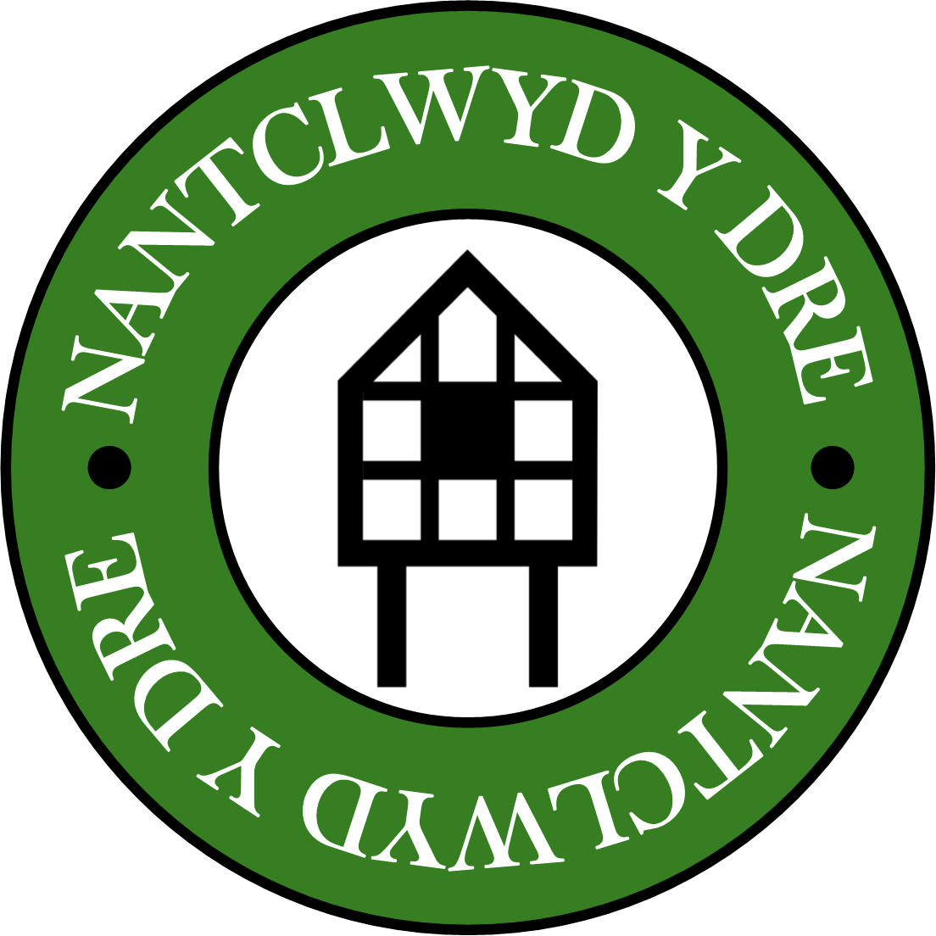 | An Introduction to drawing with pastels at  Nantclwyd y Dre Ruthin  With artist Martin Kaye  Saturday 5th April 2025 10:30am to 16:30pm

This workshop will provide a great opportunity for you to observe the period artefacts and furnishings at Nantclwyd y Dre allowing for some quality time in this wonderful historic town house.
Nantclwyd House is the oldest timber-framed town house in Wales. Parts of the current structure were begun in 1435, but there is evidence of occupation on this site dating back to the Roman period.
Refreshments will be available throughout the day, but you will need to bring a packed lunch / or you can go out into Ruthin to buy a quick lunch. The house is very central with St Peter’s Square being just a few seconds walk away.

Workshop Programme:
We will start promptly at 10:30am so please arrange to arrive a few minutes before. For this workshop we will be working entirely within the main house.
Welcome
Session 1: Introducing pastels – exploring how they blend the range of marks and effects that can be made on different coloured papers.
Break
Session 2: Exploring tone to create light and shadow, describing texture and creating depth
Session 3: Exploring aspects of composition, illustration mapping and balance.
Lunch (about 45 minutes)
Session 4: Beginning an observational drawing to create a still life composition.
Break
Session 5: Developing our observational drawings and end of session sharing.
Close: 4:30pm

Workshop Costs
The workshop costs £40 per person. Payment must be made in advance to guarantee a place. Early booking is advisable as there are only ten places on this course. All the materials required for the day will be provided. Payments are to be made by digital transfer using the details below:

Martin Kaye Artist Lloyds Bank Account No: 26995160 Sort Code: 30 95 96

Terms and Conditions: If Nantclwyd y Dre or I have to cancel the workshop for any reason you will receive a full refund. Once you’ve made the booking if you are unable to attend there will be no refund.

Location Details: Nantclwyd y Dre, Castle Street, Ruthin LL15 1DP

Parking: There is good public parking just off St Peters Square behind the Castle Hotel or at the bottom of Dog Lane off Well Street by the NFU and former red stone Conservative Club. Both are a very short walk from Nantclwyd y Dre on Castle Street.

Artist Details: Martin Kaye
Mobile: 07927796178
Web: www.fachlwyd.co.uk
Instagram: @martinkayeartist https://www.instagram.com/martinkayeartist/

